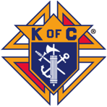Knights of Columbus Golf-A-Thon Update!
Great news on the money raised at last fall's Golf-A-Thon! The new ultrasound machine was recently delivered to the Traverse City Pregnancy Care Center. Executive Director Rhonda Wrede is pictured with her team and the new ultrasound. Their existing machine was 9 years old so this one will offer newer technology and efficiency.

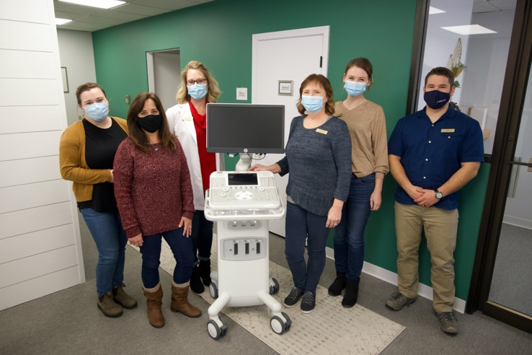

Thanks for helping the KCs "Change Lives and Save Lives". Perhaps you would like to join us in our efforts to help parish and community. Thinking about joining the St. Francis Council 13958? Contact our Membership Director Larry Herman- phone 231-357-5621
email- l.herman@mikofc.org

