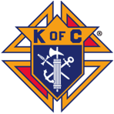The Knights Of Columbus
4th Annual Golf-A-Thon
Council #13958- St. Francis of Assisi Parish
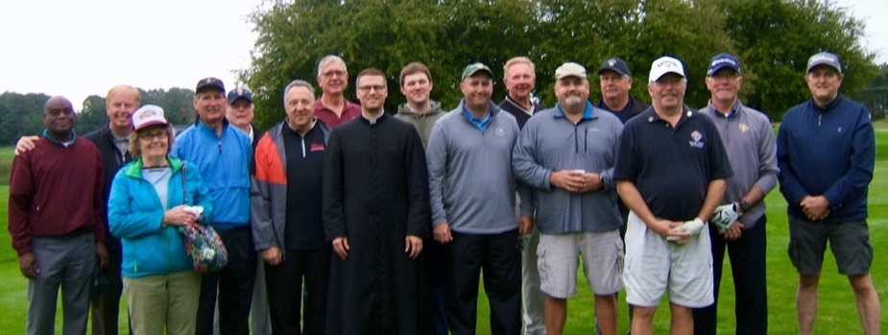

In the past three years the KC’s raised over $18,000 for the ‘Right to Life’ aspect of our faith and Catholic beliefs. This year’s goal is to purchase an Ultrasound machine for the TC Pregnancy Care Center. KC Supreme will match 50% if we can raise enough to pay for ½ of the approximate $30,000 machine cost.
A big goal, but we can do it to help support the Center and their good work.
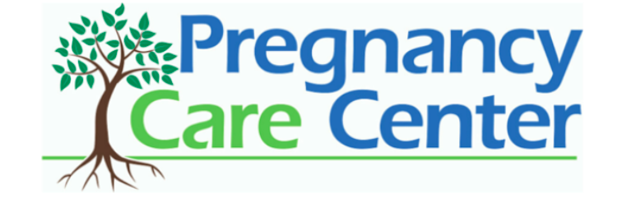
- Sunday, September 20th, 8:30am at Bay Meadows Golf Course
- 18 holes played on both the Green & Blue courses
- 4 Person teams- Scramble format- Cost $30 per golfer, includes cart.

What can YOU do!
- Sponsor a Hole for $100, signage will appear at a tee box.
- Sponsor a golfer or the event- any donation will be accepted.
- Sign up to golf and pursue your family & acquaintances for donation support.

- Contact Ken Brzozowski if you want to help this great cause!
Phone 269-598-0812 email - kbrzozowski@hotmail.com

