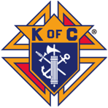 KNIGHTS of COLUMBUS NEWS!

The KC 4th Annual Golf-A-Thon was held on Sunday September 20th
at Bay Meadows Golf Course.
THANKS FOR YOUR SUPPORT!
We raised over $17,000 for the cause!
This year’s goal of raising $15,000 was to purchase an Ultrasound machine for the TC Pregnancy Care Center and WE DID THAT & MORE! KC Supreme will match 50% of the approximate $30,000 machine cost.
A big goal, but we did it to help support the Center and their good work.
In the previous three years we raised a total of $18,000 from the Golf-A-Thon events, which was donated to right to life agencies in the TC area.
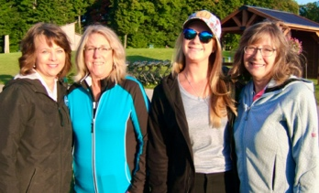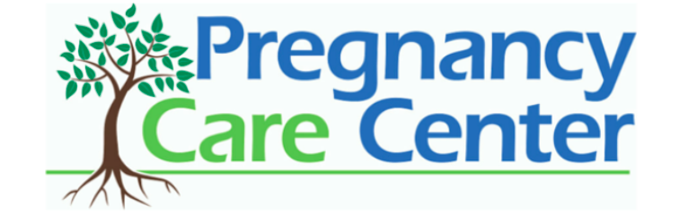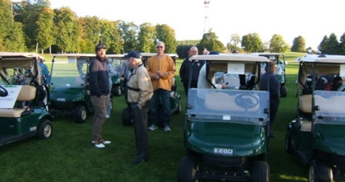
Donors/ Holes Sponsors
Many friends, family members, parishioners and businesses drove the success of the event with generous donations & support. Thank you all!
YOU MADE IT HAPPEN!
We continue to “Change Lives & Save Lives” with your support!

The KC Piggy Raffle drawing was Friday, September 25th with Fr. Don Geyman, Pat & Andrew Lints (pictured) drawing the winning ticket!
The two winners were Christina Mikowski and Claudia Demers!
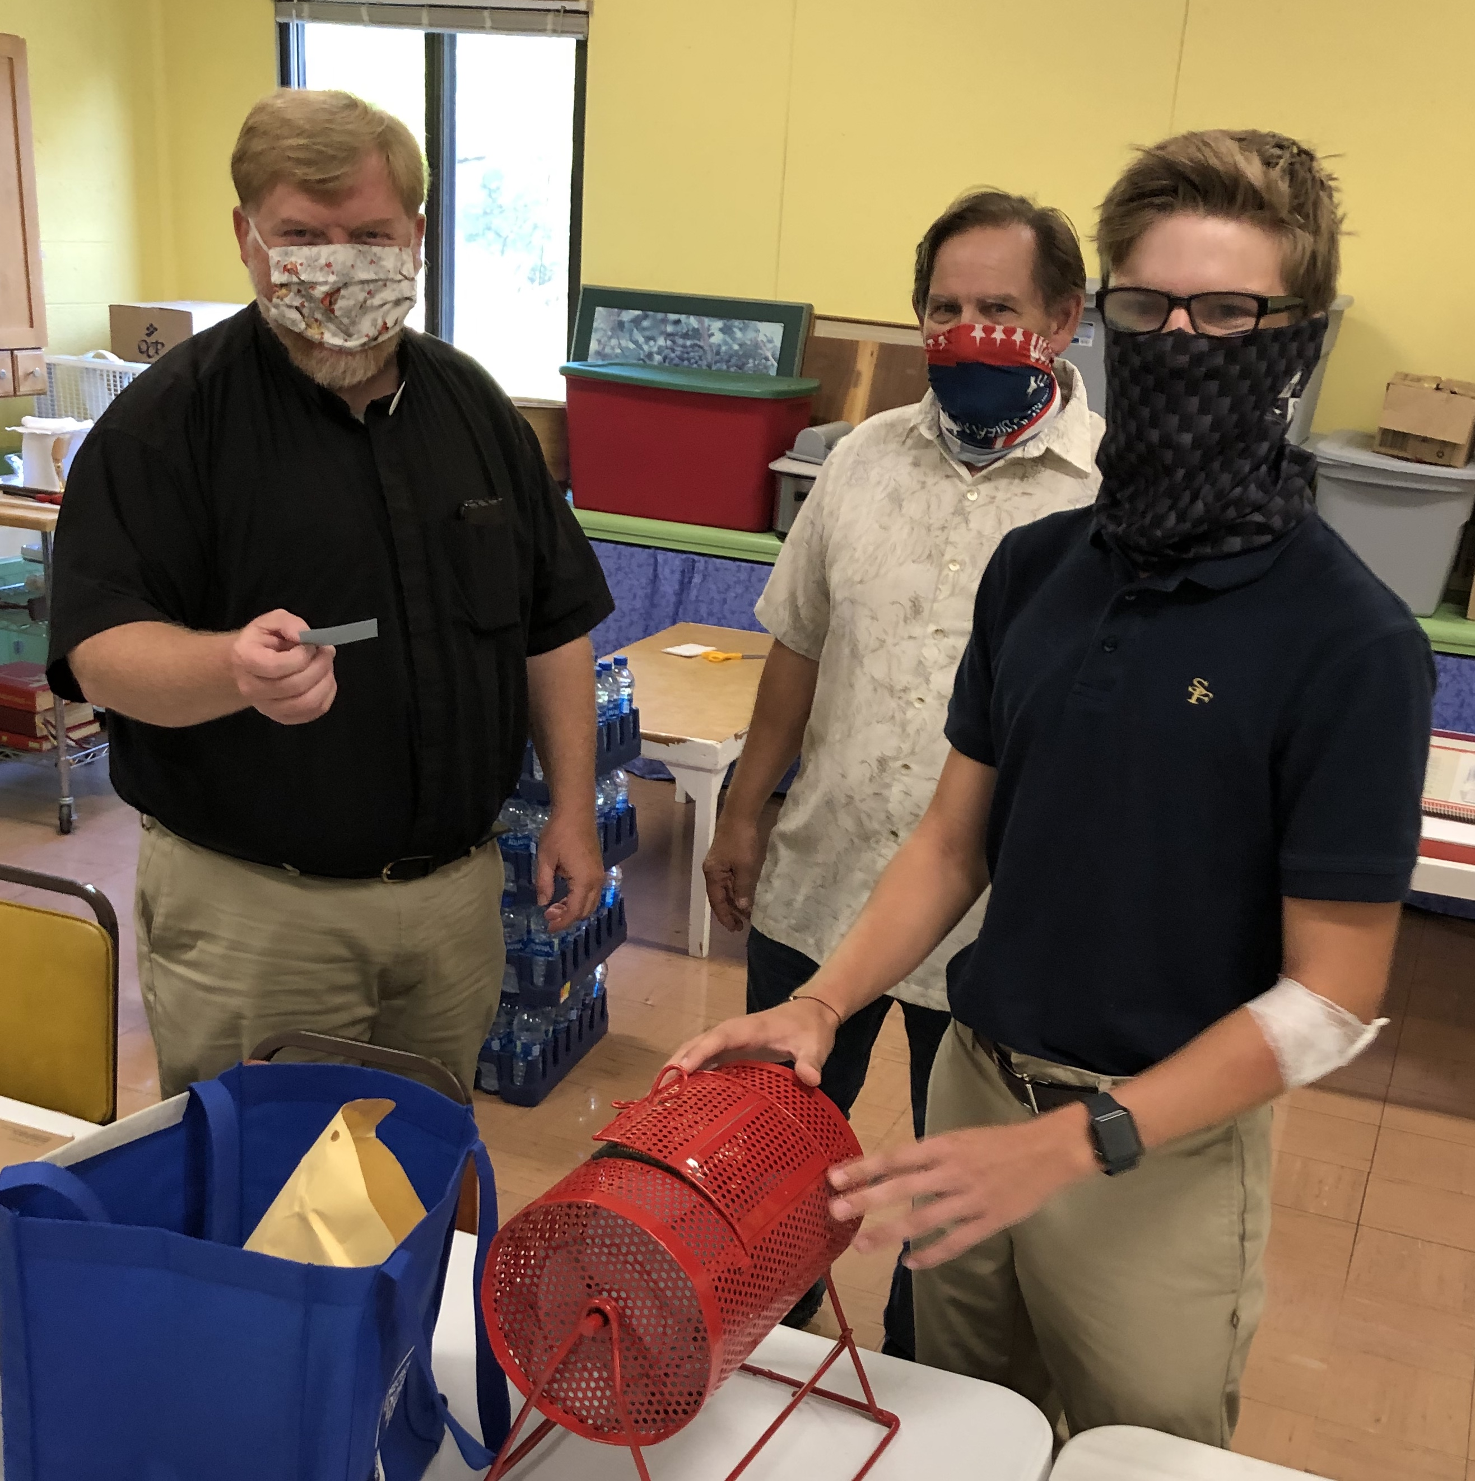
Each winner received ½ of a butchered hog. Thanks to Ebel’s for processing the meat.
Thanks for all your support in making this event a booming success with over $3,000 profit.
Hats off to Pat Lints and Al Henning for coordinating, and thanks to Andrew Lints for raising the Piggy. We will be making donations ($1,571.74 each) to Fr Fred's and the GTACS KC Scholarship award which will be used in conjunction with this year's Gladhander event.
___________________________________________________
Upcoming- Mass for the Unborn
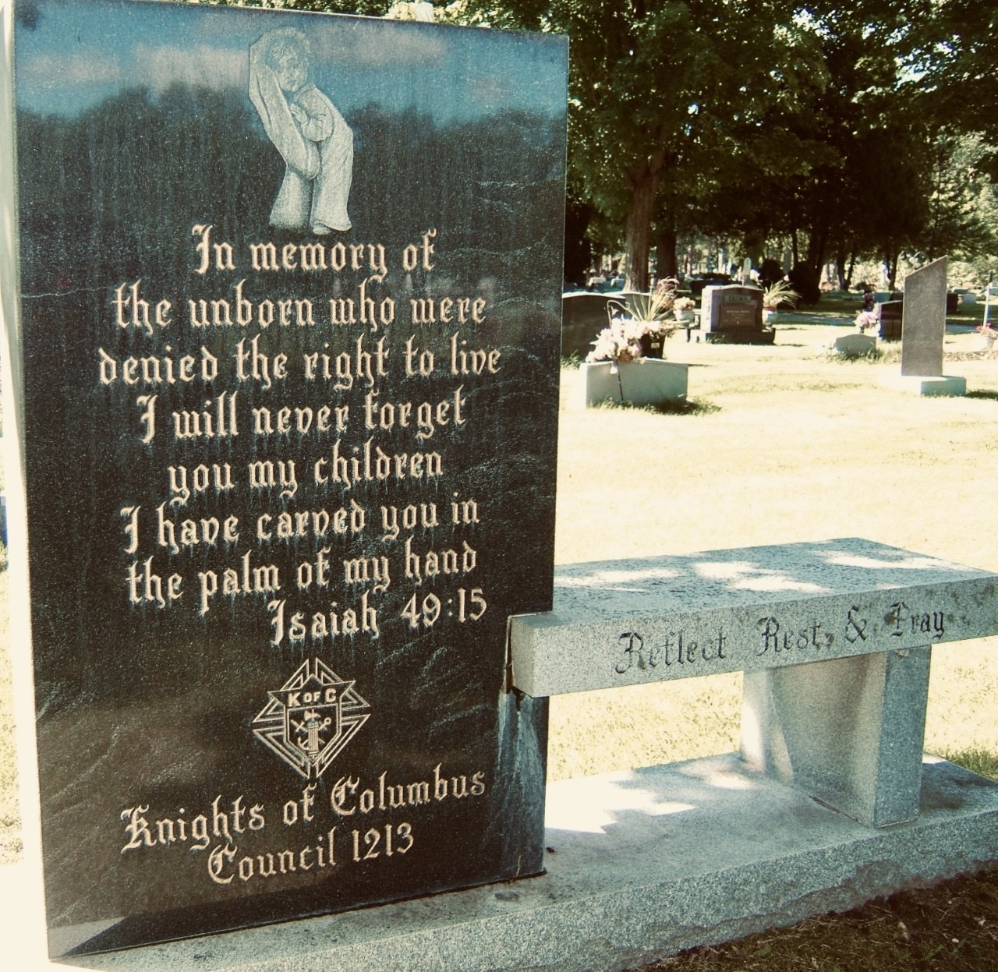
Mark your calendars!
Saturday, October 17th 9:00am at St. Francis Church (indoor).
Note new location for the Mass.

